**FINAL ASSIGNMENT**

**Creating Author Portfolio Website**

**Steps:**

* First creating 4 pages HOME, BOOKS, ABOUTME, CONTACT ME for giving the header in the author portfolio.

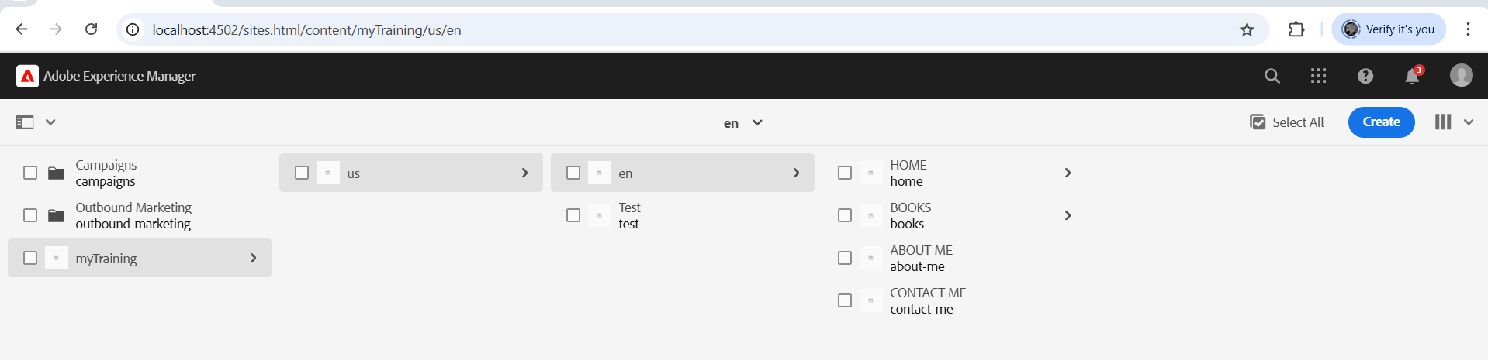

* Creating the header using experience fragments and using the created home, book, about me and contact me page for redirecting it to the specific pages for knowing more information.

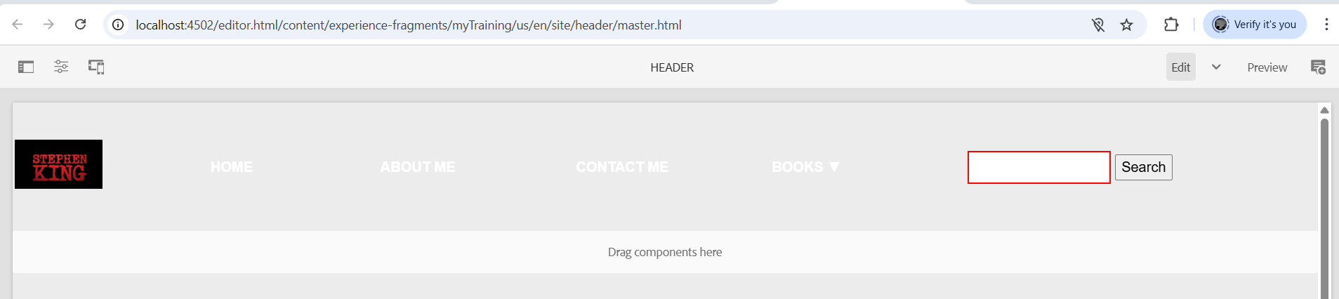

* Here the text colour is white as I need to provide some background colour stylings through css which is done in the next step.

* Creating footer using experience fragment to style the footer as per requirement in providing the links of main pages which will redirect us to the exact destination as per our requirement.

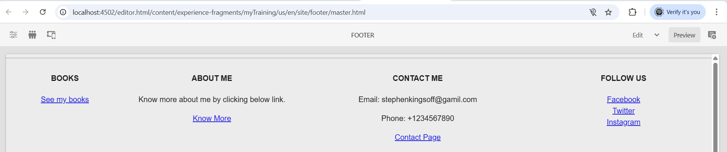

* Adding header.scss in the code for the styling in header like changing the background colour and text colour for good presentation and visibility of the website.

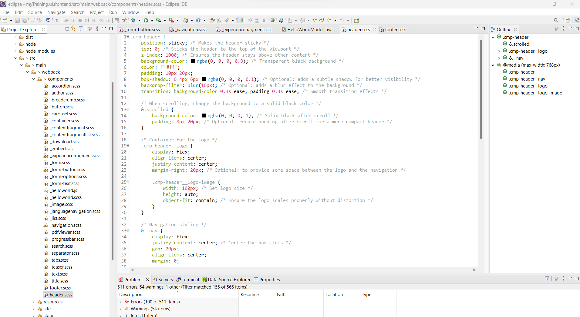

* Creating footer.scss like header.scss for similar styling of footer



* Next editing the HOME page by adding content pages for the awards received by the author in which the award description will be given.

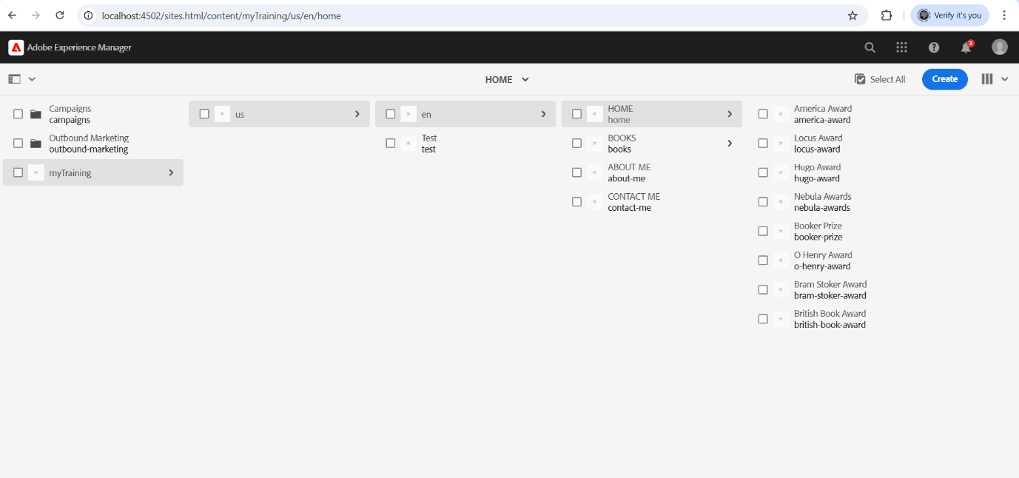

* Adding the books written by the author in the book page which will have the book description

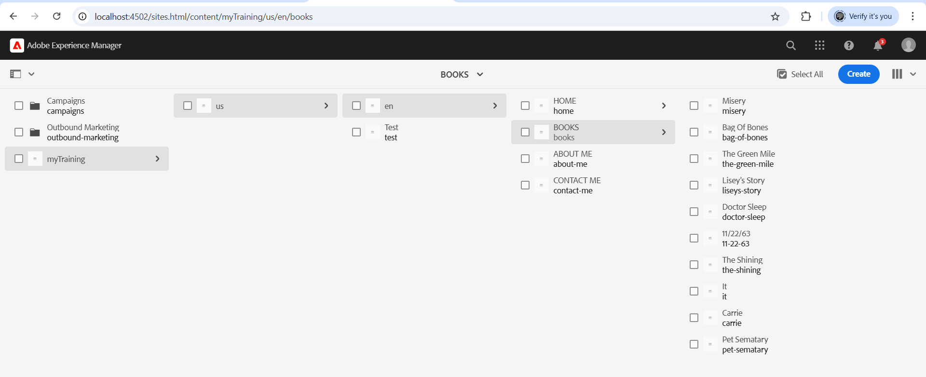

* Creating the header and footer styling and creating the home page with adding the award details of the author using teaser component by adding cta for it as per requirement.

* Adding Award Details:

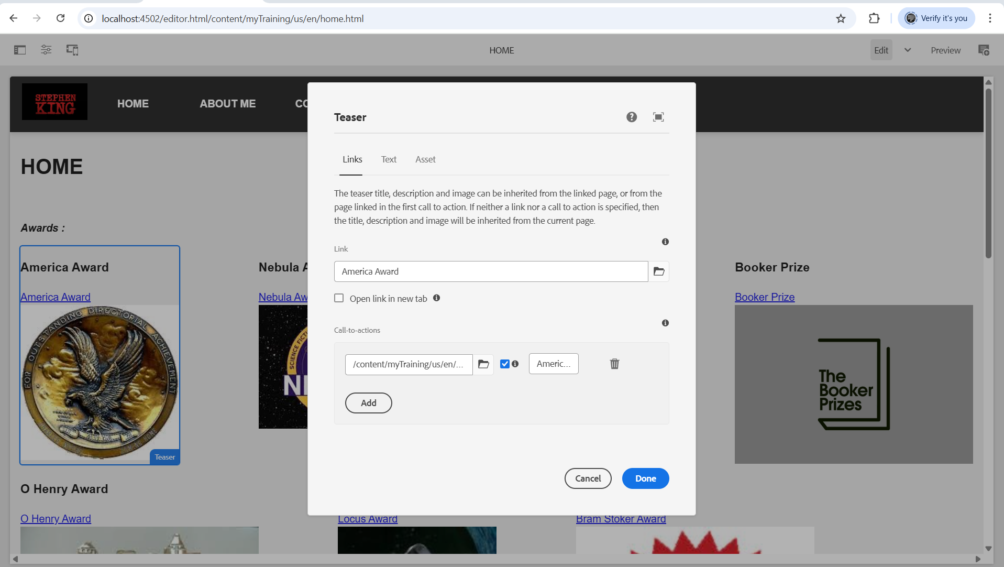

*Adding all the awards using teaser component and linking it to its main page

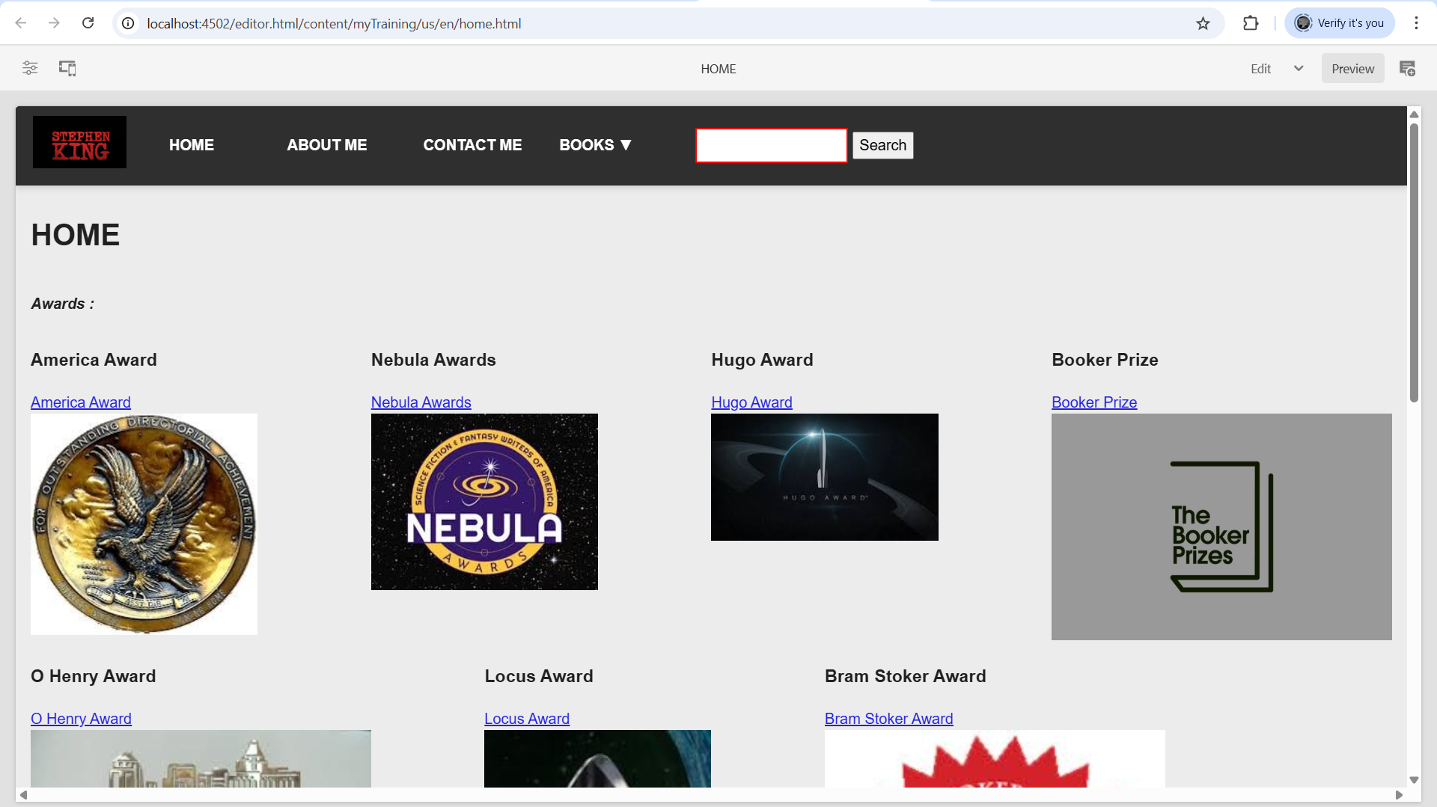

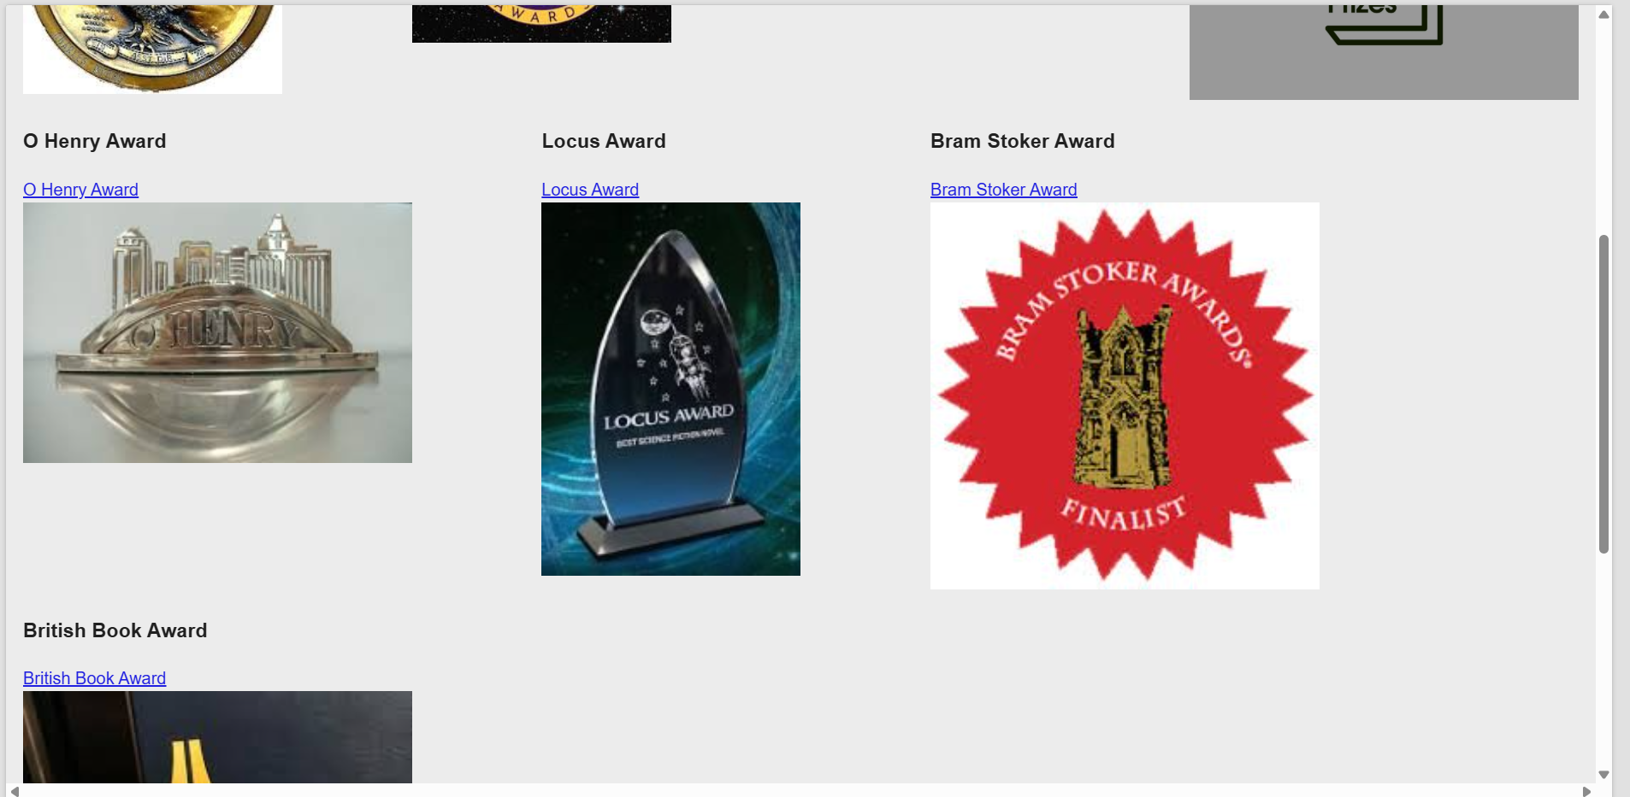

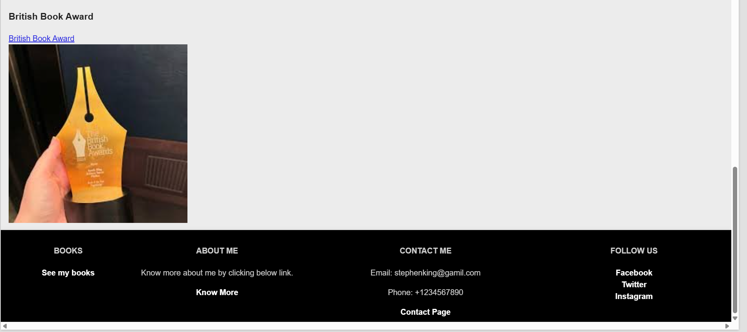

* Now in the teaser component the award page is linked to the specific award we need to know about so if we touch any award it will redirect to that award page which has the description of the award received by the author.

1.America Award

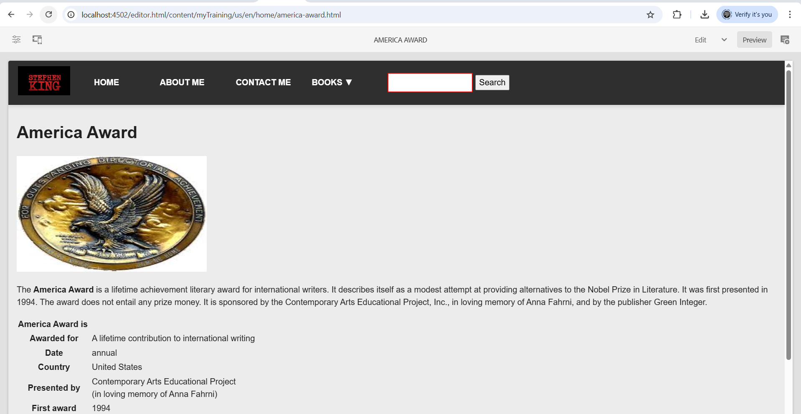

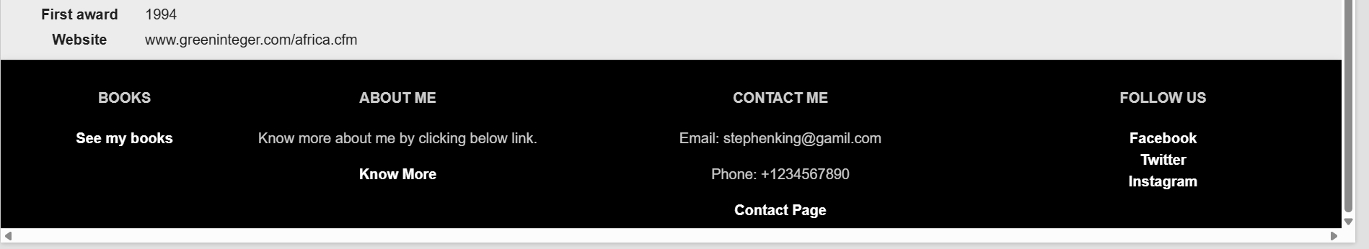

2.Nebula Awards

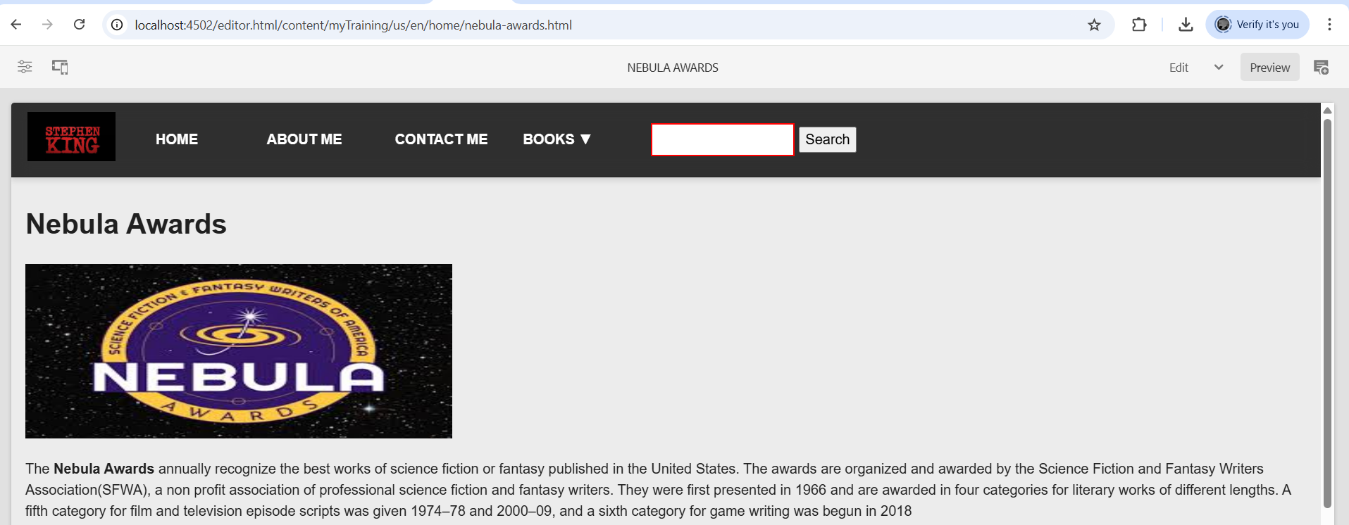

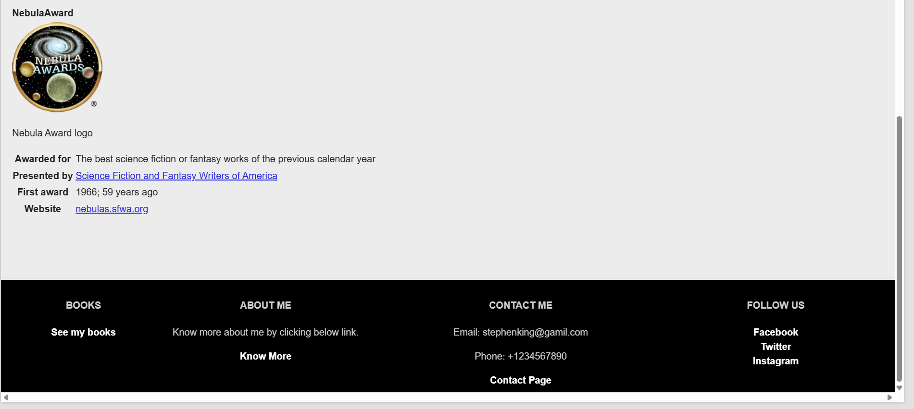

3.Hugo Award

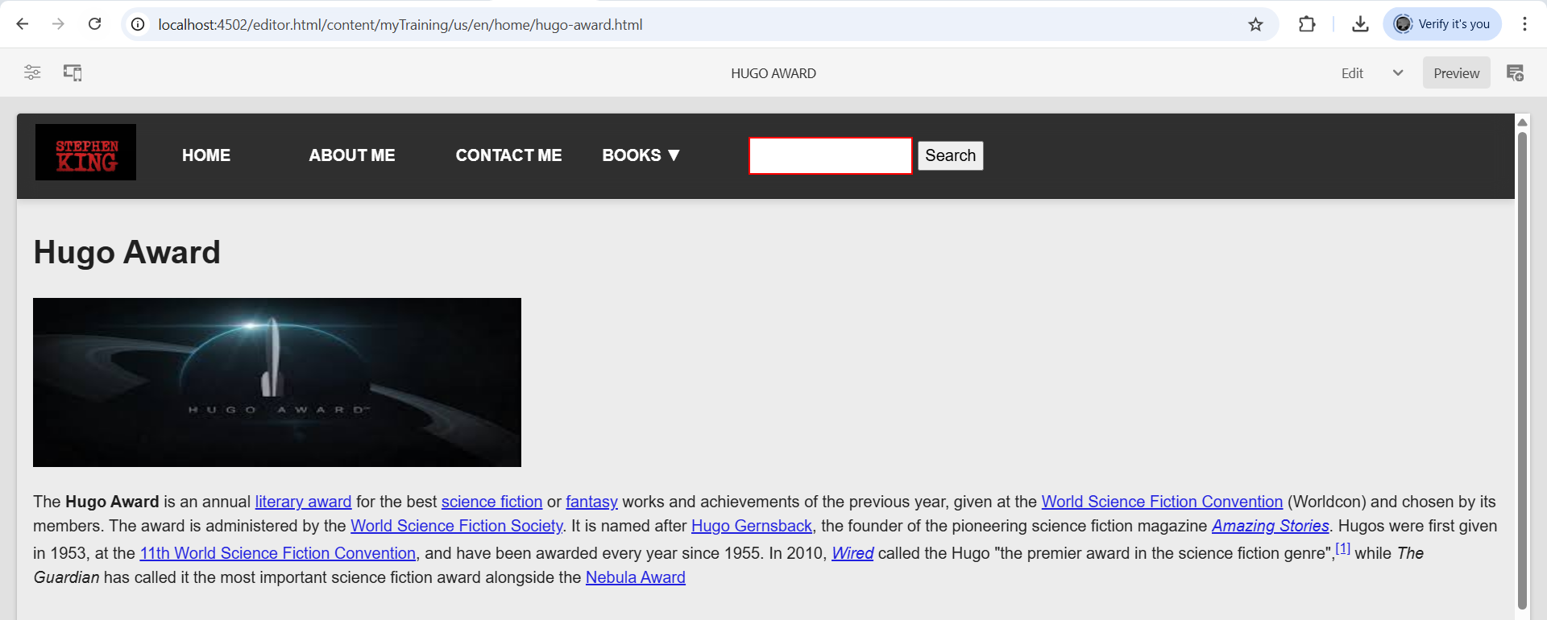

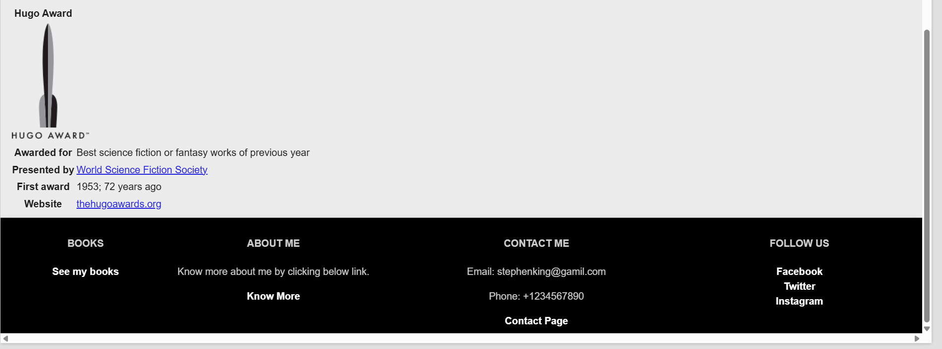

4.Booker Prize

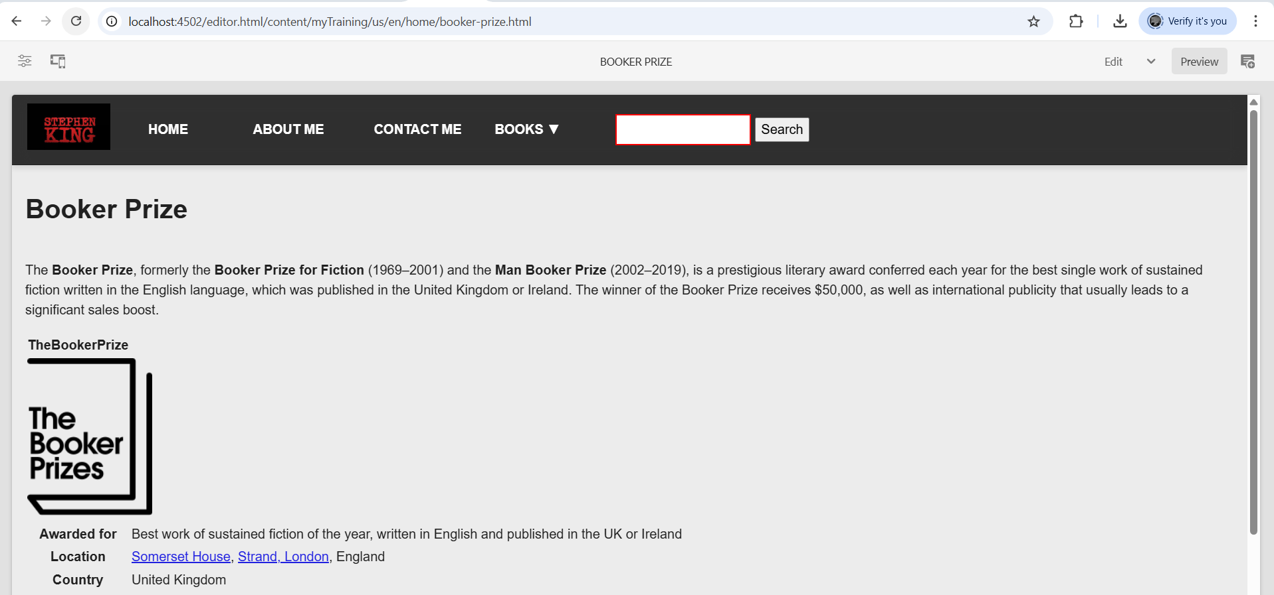

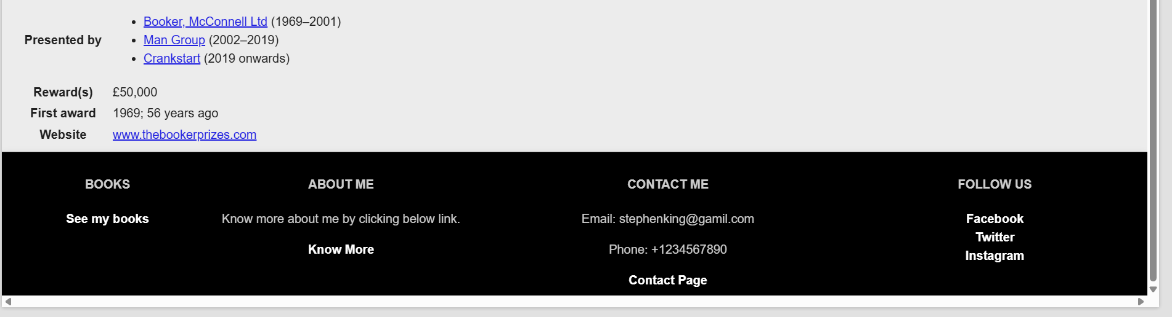

**All the awards will be redirected to its description page while clicked. For reference only 4 awards are displayed.

* Next creating the About me page using author component to show the author details briefly.

* Adding details:

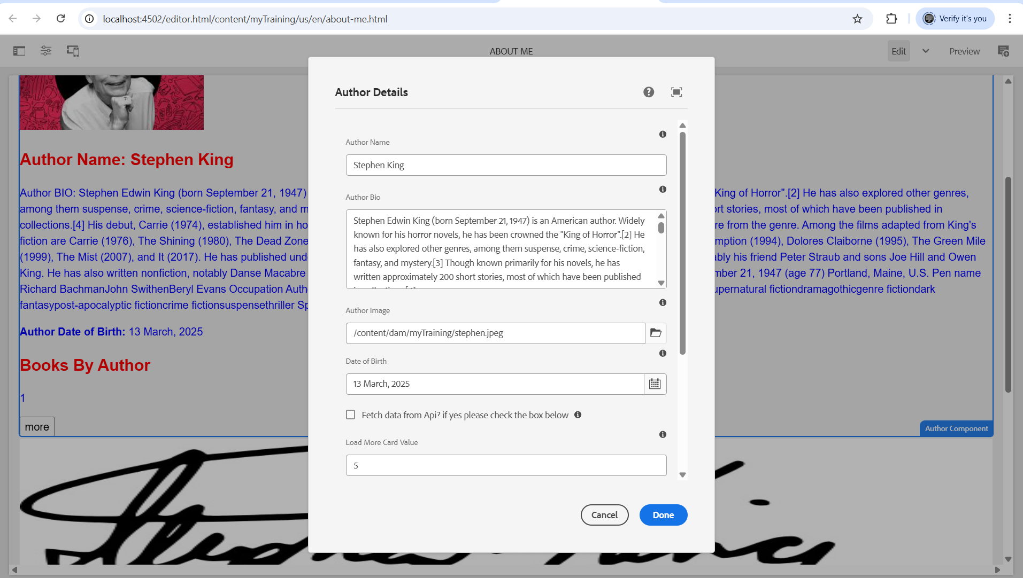

*Review:

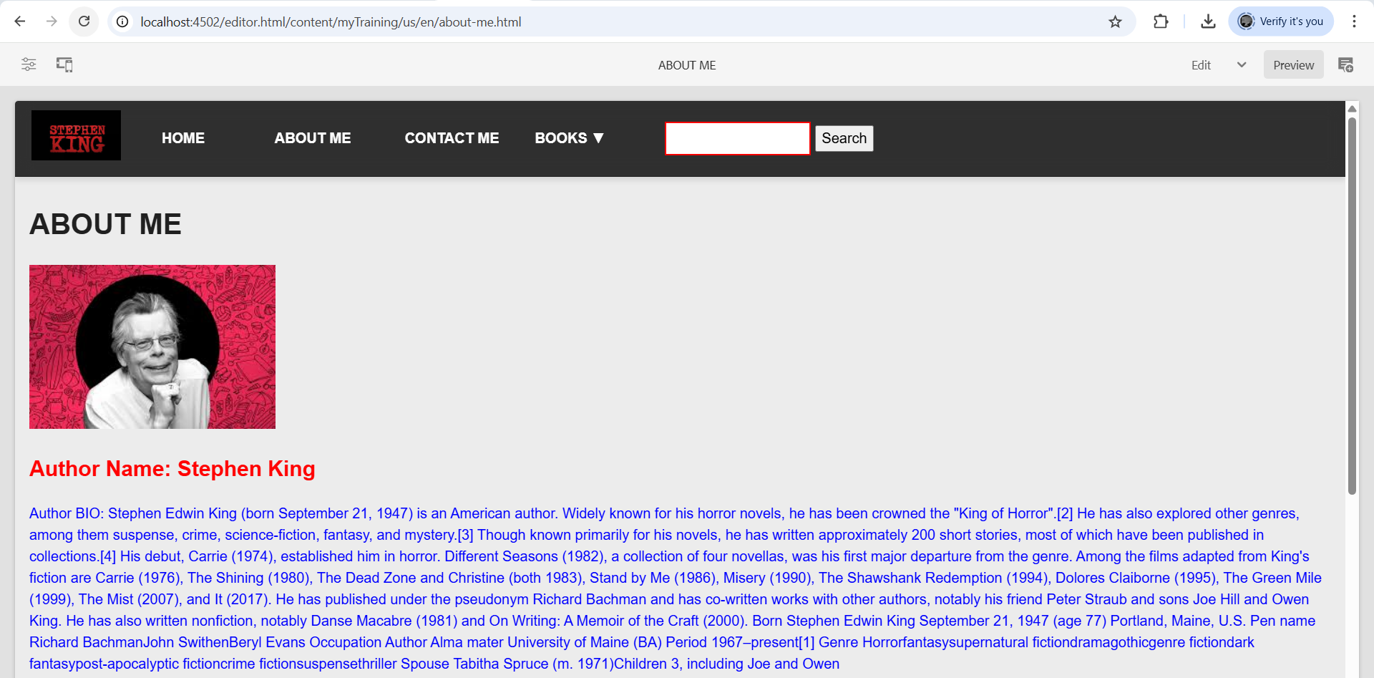

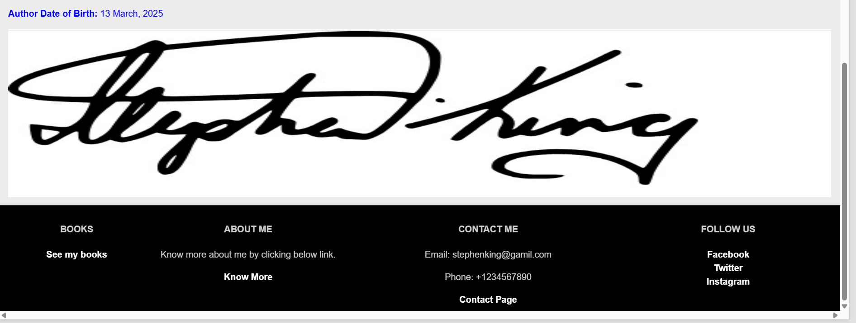

**\*\*** Added signature using image component below the author component

**\*** Next creating the Contact me page using the text box and adding the contact details of the author

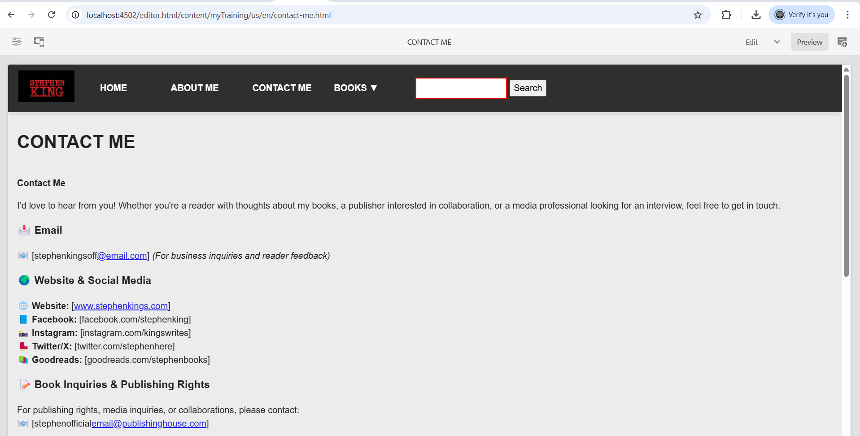

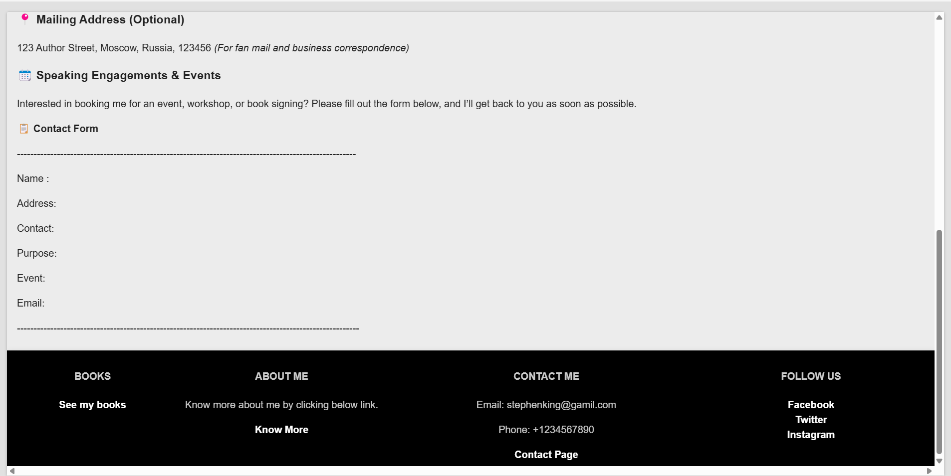

**\*** Creating Books page using book component and creating cards for the books written by the author

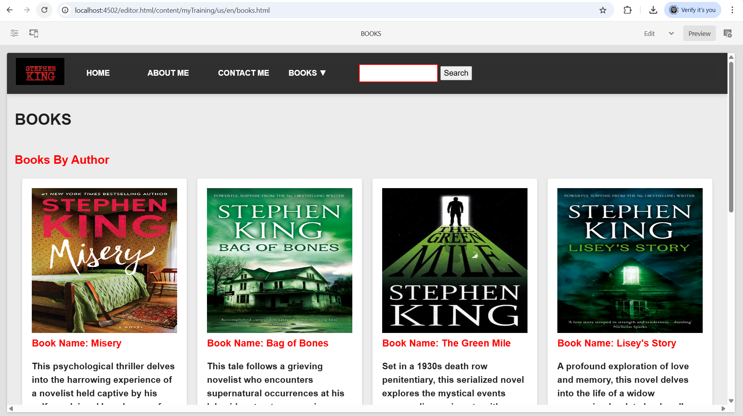

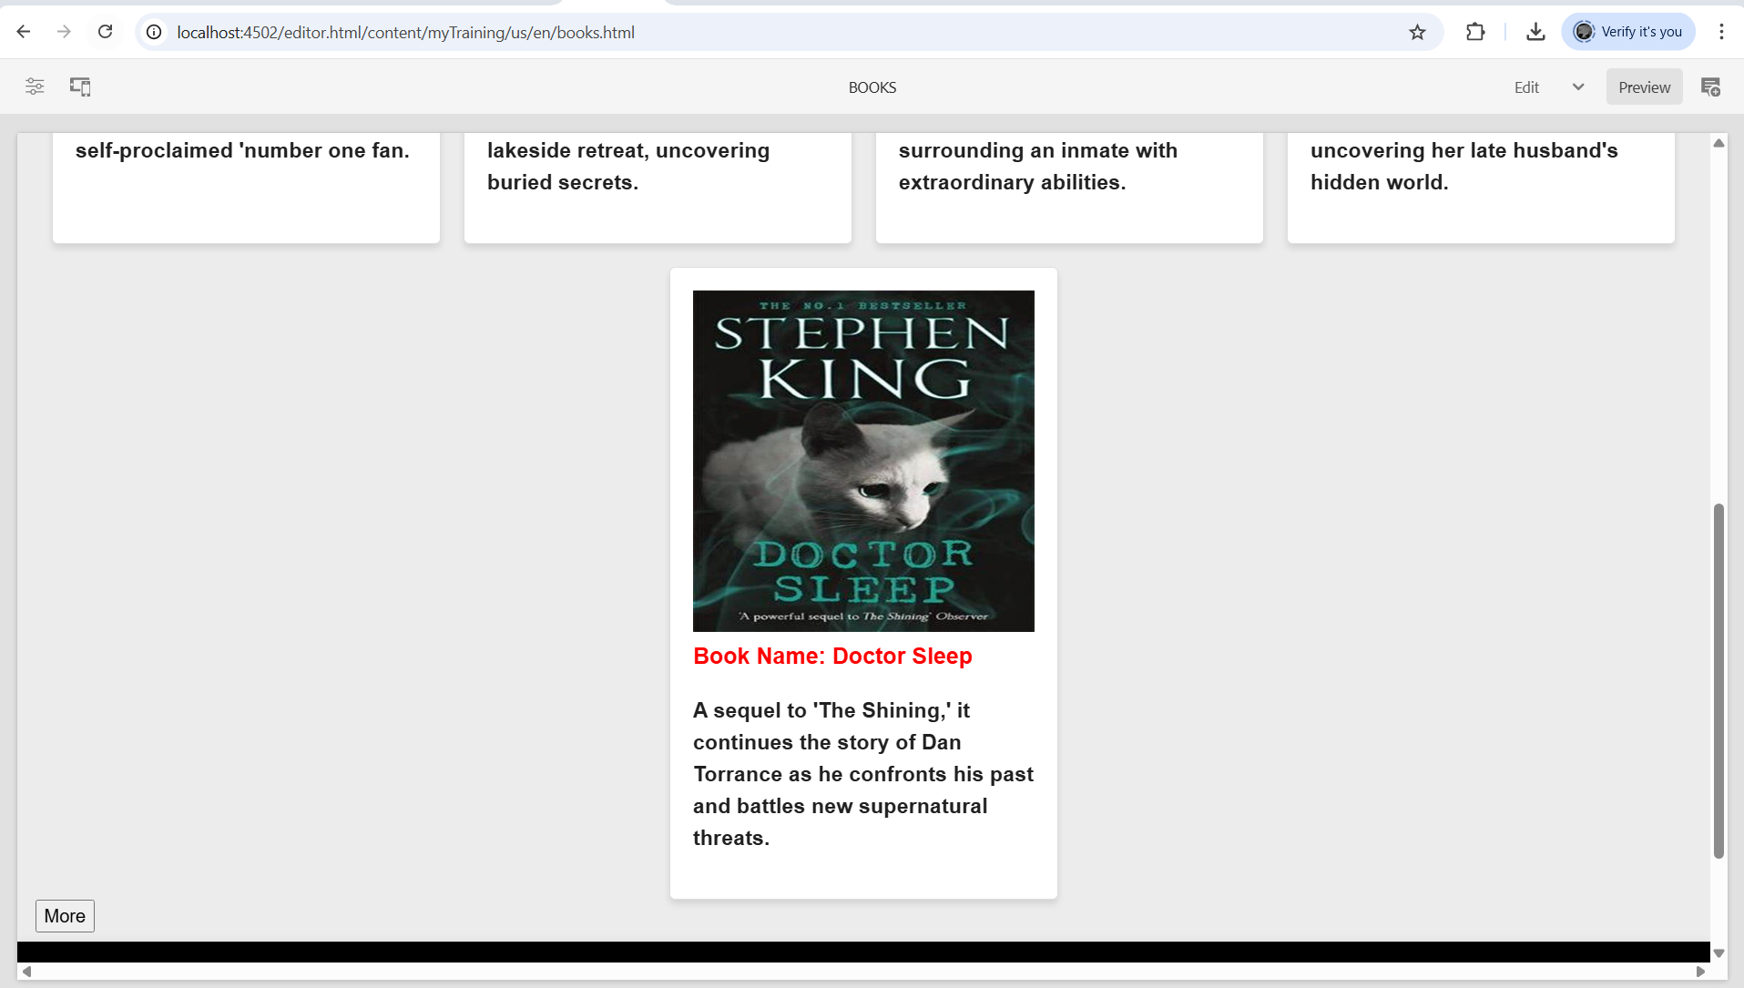**\*** After touching the more button other books of the author will be visible

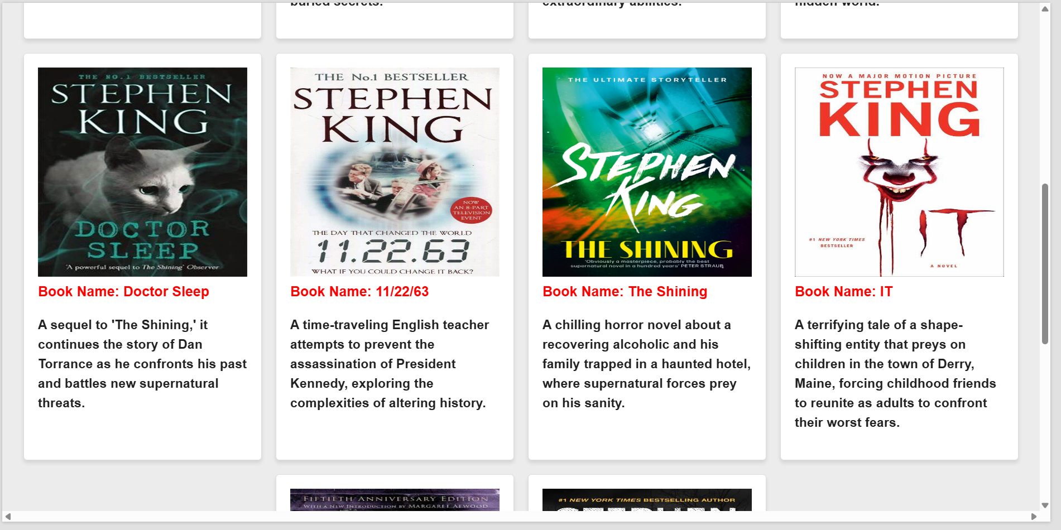

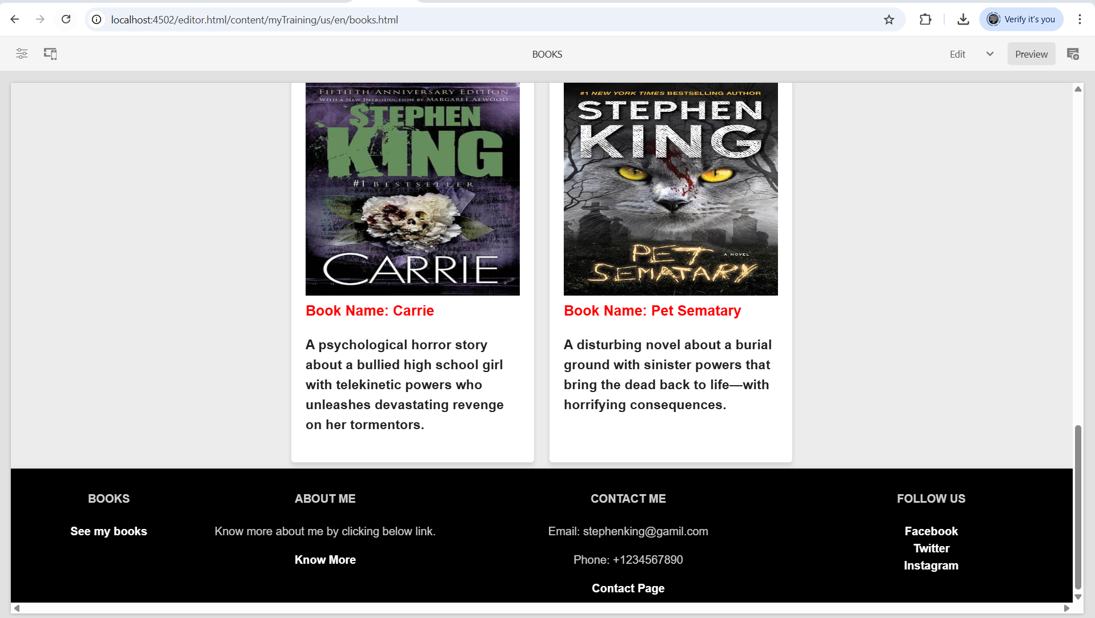

* Creating dropdown list for all the books of the author and is provided as a link so that if we touch the book name it will redirect to the page containing details of the books written by the author

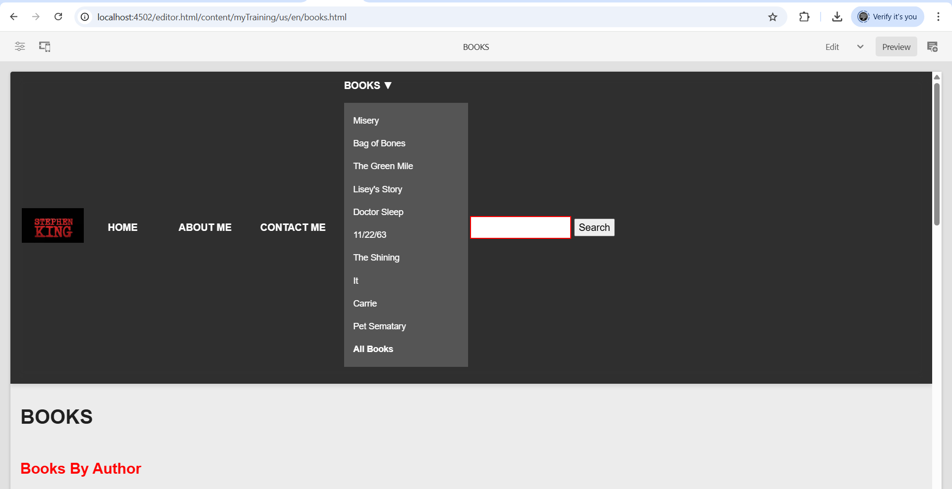

**\*** Touched on the book Misery and redirected to misery book page

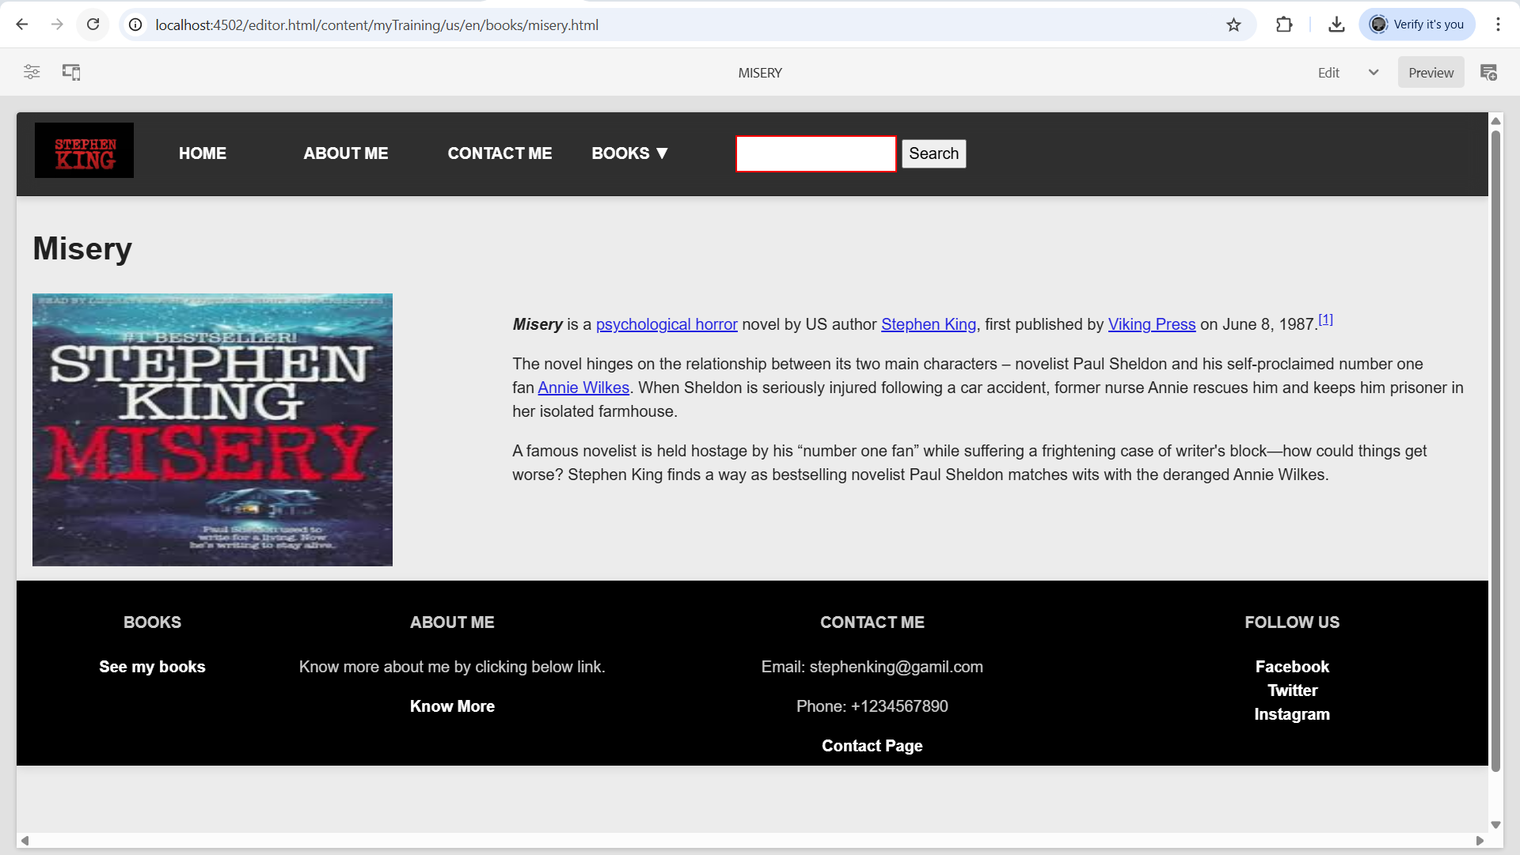

**\*** Bag of Bones

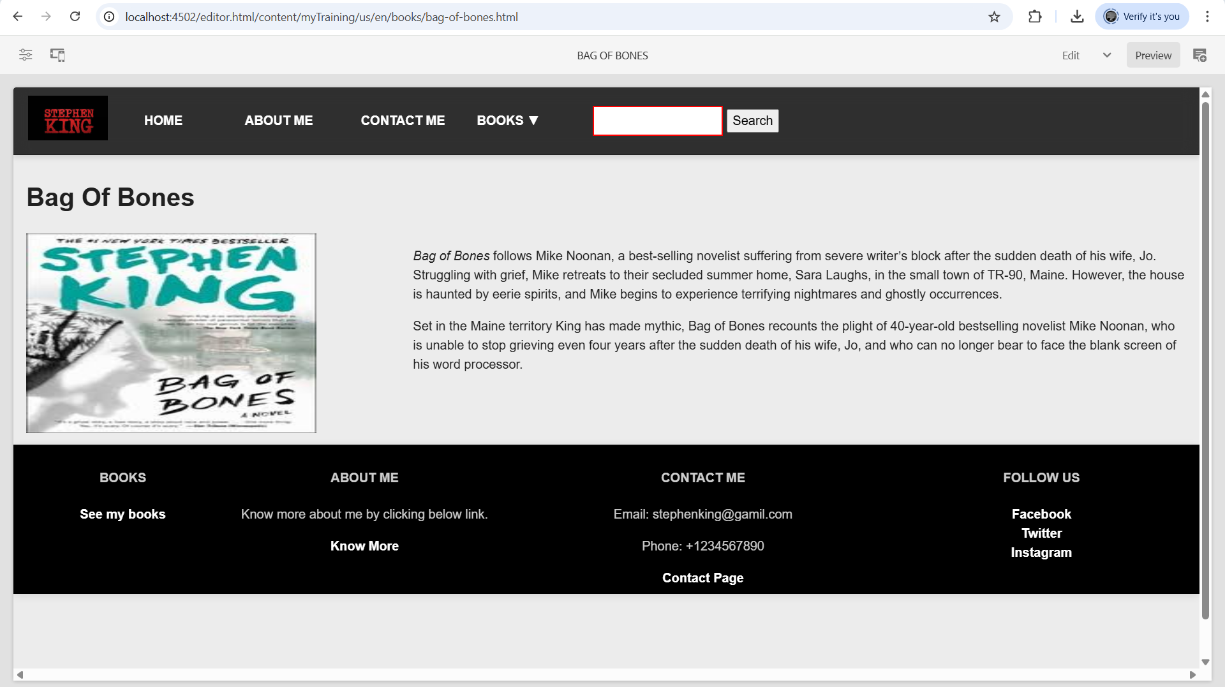

* The Shining

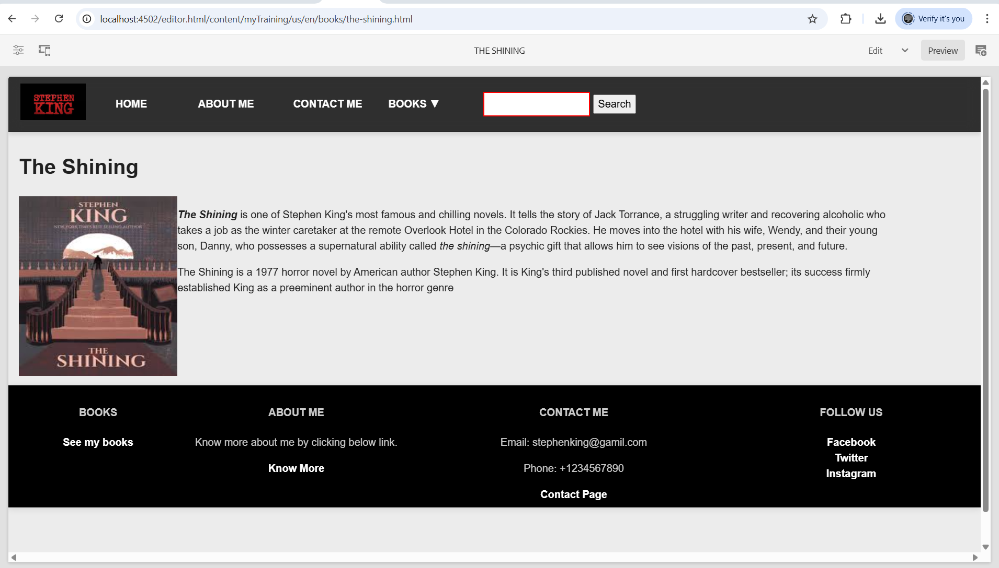

* IT

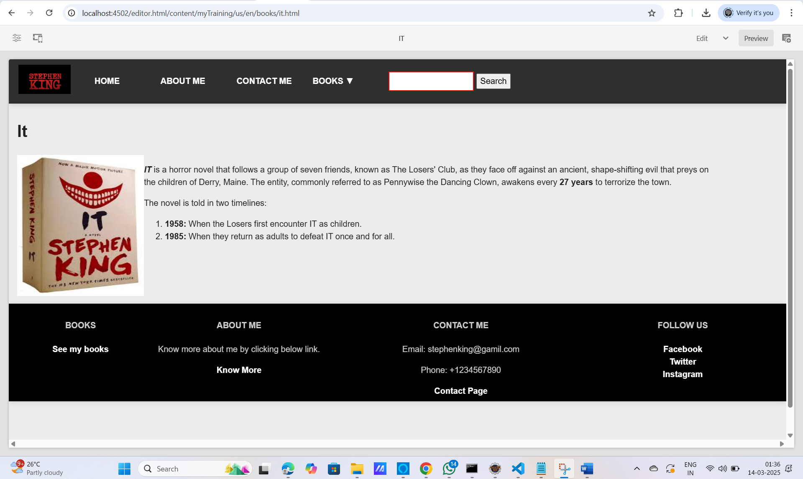

**\***Used author.html code for the author component

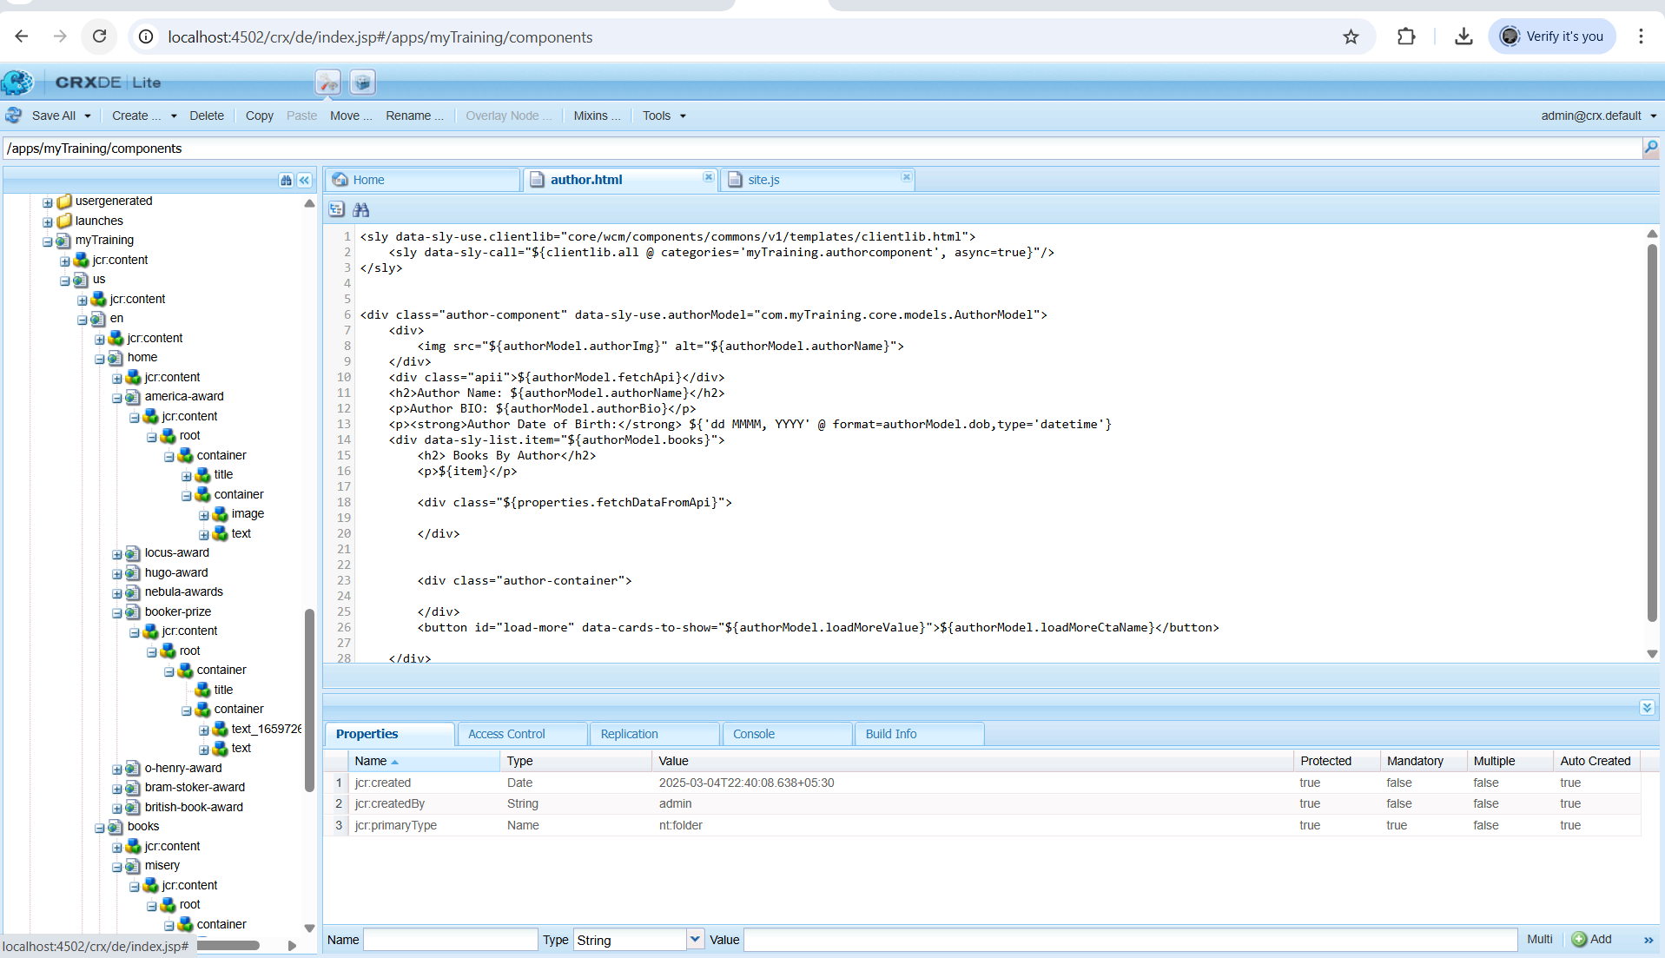

**\***Used site.js code for the connection with third party custom api to fetch the data in cards form

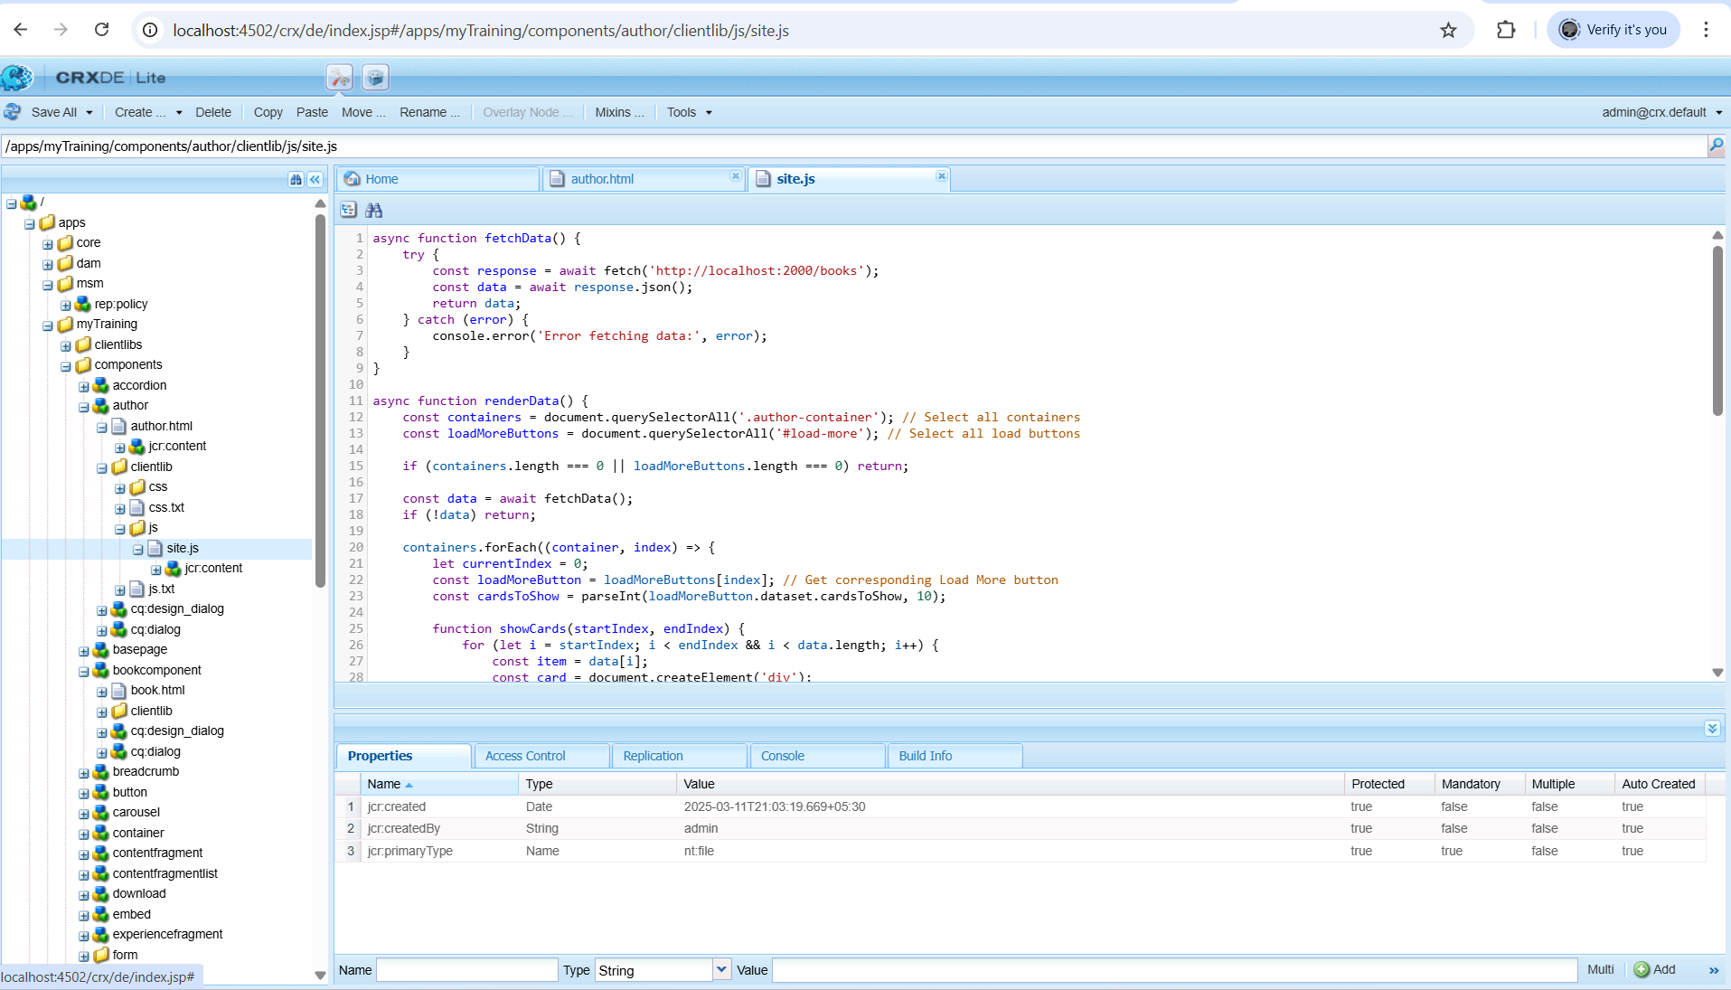

**\***Third party custom api file in which the book details are predefined as the bio , book name , and image url which is needed to be printed on the card format.

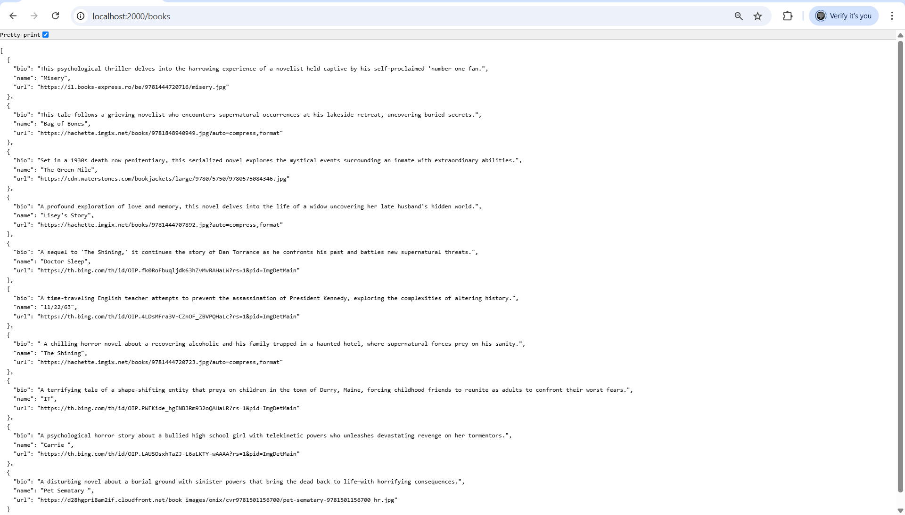

**List of Components used:**

1. Expereince Fragment – Header

Footer

1. Author Component
2. Text Component
3. Teaser Component
4. Book Component
5. Image Component
6. Button Component
7. Quick Search Component

**Requirements Satisfied:**

1. Created 4 pages about details of author like Home, Aboutme, Books, Contactme for adding them in header and footer.
2. Created Header and footer styling through experience fragment and header.scss and footer.scss .
3. Created Award pages using content page for each award received by the author, under home page so that each award can be viewed briefly in this specific award page.
4. Created Book pages using content page under the Books page for describing about the authors each specific book in detail.
5. Created Home page containing awards of the author using teaser component and linking it to each of the specific award page which has its full description.
6. Created About me page using author component by providing details of author like name, bio, image and date of birth.
7. Created Contact me page using simple text box in which the authors contact details are provided.
8. Created Book page which displays the books of the author in card format and also has a dropdown list in the header for books which has the list of all the books of author .It is also provided as link so that if we touch that book name it will redirect to the specific book page which has its description.